

Internet of Things Workshop

Lab 3

Working with Event Streams

Change Record

|  |  |  |  |
| --- | --- | --- | --- |
| Date | Author | Version | Change Reference |
| 10/7/2015 | Chmitch | 1.0 | Initial draft |
| 1/13/2016 | Chmitch | 1.1 | Updates based on beta testing by Steve Busby |

Table of Contents

Change Record 2

Introduction 4

Environment setup 4

1.) Create a Stream Analytics Job 5

2.) Defining the Inputs 7

3.) Writing the Streaming Query 9

4.) Define the Output 10

Introduction

This lab is focused on configuring an Azure Stream Analytics for aggregating your Internet of Things sensor events, and outputting the data to a variety of destinations. This lab is the third in a series that walks through building an end-to-end Internet of Things prototype for doing temperature monitoring.

In this series of labs you will:

1. Assemble an Arduino Uno device for temperature monitoring using a prototype kit, and code and deploy a sketch using the Arduino IDE.
2. Write a gateway application (Universal Windows App) on a Raspberry PI to receive the serial data from the Arduino and send data to an Azure IoT Hub.
3. Configure Azure Stream Analytics jobs for gathering and aggregating streaming data for reporting purposes.
4. Build a Power BI dashboard for visualizing real-time and historical event data from the sensor.
5. Integrate the gateway app with the Azure IoT Suite Remote Monitoring pre-configured solution.

At the end of this lab you will have routed your events to Azure Blob Storage and be ready to route events to Power BI.

Environment setup

This lab module uses only Azure components so as long as you have a browser you’re ready to go.

1.) Create a Stream Analytics Job

In this section you will create a new Stream Analytics Job and validate events are flowing properly.

1. Using a web browser navigate to portal.azure.com
2. Create a new Stream Analytics Job from the portal navigation using + New -> Internet of Things -> Stream Analytics Job.  
   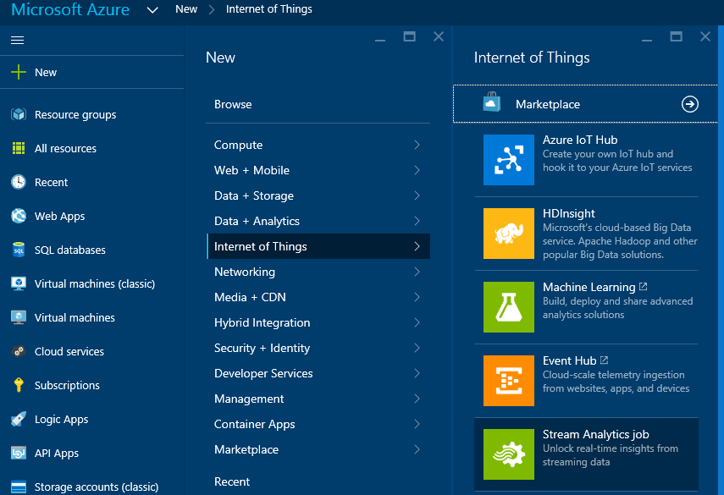
3. You’ll be presented with the create pane for Azure Stream Analytics. Enter “studentxxsa” for the Job NameQuick Create” screen for event hub creation. On this screen enter a unique name for your event hub student<xx>eventhub choose the resource group “student<xx>iot”, pick Central US for the location, and finally click .   
   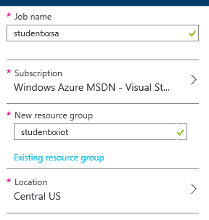
4. You will be presented with a progress indicator while the job is creating.  
   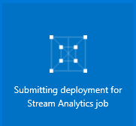
5. Upon completion you’ll be presented the main blade for your stream analytics job.  
   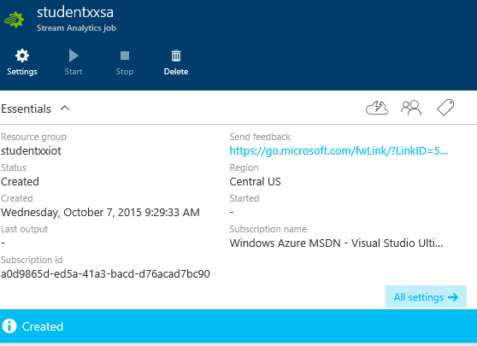

2.) Defining the Inputs

In this section we’ll define the inputs to the Azure Stream Analytics job. This configuration binds to the Azure Event Hub as an input source.

1. Under “Job Topology” click on “Inputs”.  
   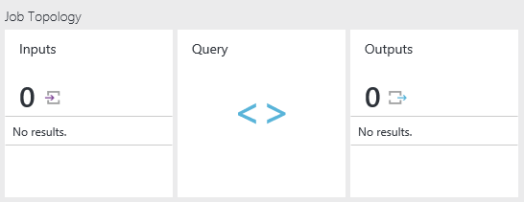
2. You’ll be presented a blank list of inputs. Click the Add button .
3. On the “New input” screen complete the details based on your configuration in lab 2.  
   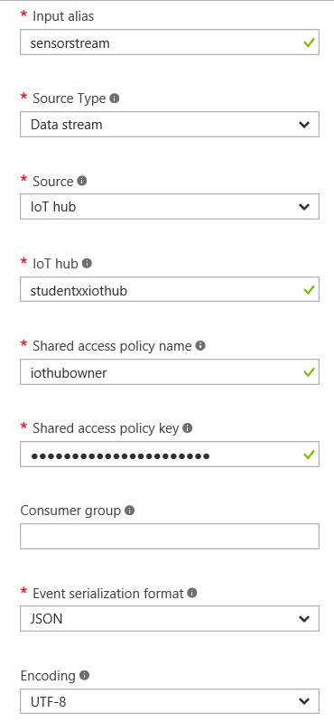
4. Click the button.

3.) Writing the Streaming Query

In this section you will write a streaming query that defines how you handle the data arriving in the event hub. Note your query can work with multiple inputs and join them together. In this scenario we’re only working with a single input.

1. Click on the “Query” button from the “Job Topology” screen.  
   
2. You’ll now be presented a basic starting point for a query.  
   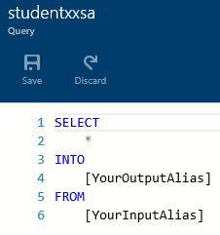
3. For our query we need to get an average of temperature and humidity over a 10 second window. The following query will provide this capability to us.  
     
   SELECT  
    AVG(CAST(s.humidity as float)) Humidity,  
    AVG(CAST(s.temperature as float)) Temperature,   
    System.Timestamp as EventTime  
   FROM sensorstream s  
   GROUP BY TumblingWindow(second, 10)
4. Click on the  button to store the query.

4.) Define the Output

In this section you will define the output destination. We’re using a Power BI output for this solution, which is not currently available in the preview portal so we need to navigate to the current azure portal at [http://**manage.windowsazure.com**](http://manage.windowsazure.com)

1. Click on the “STREAM ANALYTICS” button form the navigation pane.  
   
2. Click on the “student<xx>sa” stream analytics job.  
   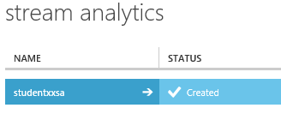
3. Click on the “OUTPUTS” tab.  
   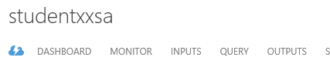
4. Click on the “ADD AN OUTPUT” button.  
   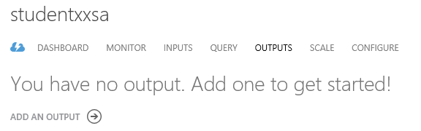
5. Select the “Power BI” option and click the next arrow.  
   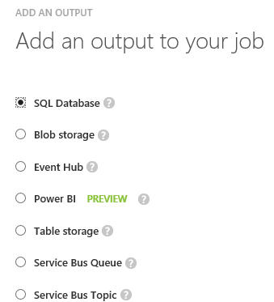
6. At this point you can either leverage an existing Power BI account or create a new one. Click the appropriate option based on your scenario. For the purposes of this lab we’ll follow the “Authorize Now” route.  
   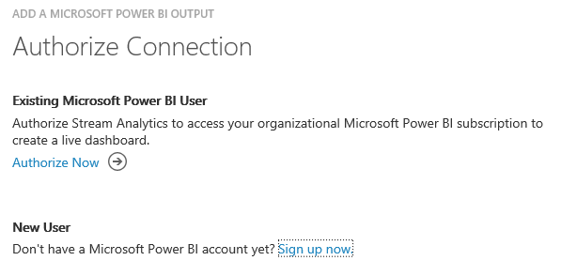
7. Complete the Power BI output details as follows:  
   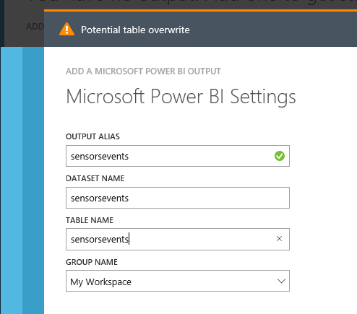
8. Click the check button to complete the Output creation. 
9. Congratulations, creation of your Azure Stream Analytics Job is complete. Click the “START” button to run the job.   
   
10. Note… This job captures a stream from the event hub, but for any output to occur it assumes that your gateway is sending data to Azure. If your event hub isn’t running, now is a good time to start it up.